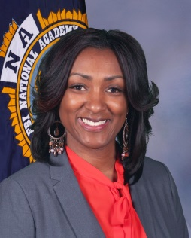Jerri Sutton is a 25-year member of the Chattanooga Police Department assigned to the Office of the Chief of Police. As chief of staff, she manages department projects; oversees new contracts and grants; and assists the chief of police with the duties of the office.

1999-2024

**Officer Biography**

**Chief of Staff, Jerri Sutton**

**Chattanooga Police Department**

Prior to her appointment as Chief of Staff, Sutton oversaw the criminal investigation and special operations division at the Chattanooga Police Department where they maintained a clearance rate of 83%, which is above the national average. Throughout her career, Sutton had the privilege of serving as the department’s Public Information Officer where she developed a comprehensive media strategy that enhanced transparency and community relations.

Sutton was the Director of Training where her division was recognized as one of the top academies in the state of Tennessee for reaching mandatory and enhanced training benchmarks. As Director of Training, Sutton developed the department’s first online training module that is still in use.

Sutton touts a list of personal accomplishments but says her most notable accomplishments have been in serving youth of the community and enhancing the department initiatives that foster community relations. One of the most successful programs was Cops and Kids Kickball.

Sutton has been recognized by several community organizations in Chattanooga. She has received awards for innovation, community partnerships, and outstanding service.

Sutton serves as the president of the Tennessee Chapter of the Federal Bureau of Investigations National Academy (FBINA), and President of the Southeast Tennessee Chapter of NOBLE. She is a financial and active member of Zeta Phi Beta Sorority, Inc. where she currently serves as the state of Tennessee’s Safety Coordinator and is the chair of the Chattanooga Chapter of the National Panhellenic Council’s Greek Cookout. She is the mother of one son, Jordan Atkins.

It has been her goal to be a leader in law enforcement and be a change agent for 21st Century Policing. Sutton believes the pathway forward is with diverse community input, innovative strategic planning and improved legitimacy in law enforcement. She knows that law enforcement alone isn’t enough, but, together, we can do all things!