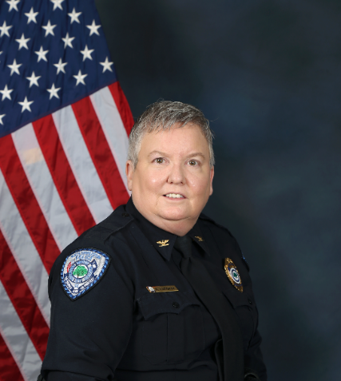

Deputy Chief Karen R. CORDRAY

Deputy Chief Cordray, a native of North Charleston SC, graduated from Gordon H. Garrett High School and attended the College of Charleston. She began her career with the North Charleston Police Department in June 1992 and graduated from the South Carolina Criminal Justice Academy in 1993 as a Distinguished Graduate.

Early in her career, Deputy Chief Cordray implemented the department’s Records Management System and established the Crime Analysis Unit. She later transitioned to the Patrol Division, where she became a Field Training Officer and was promoted to Corporal in 1998.

From 2000 to 2007, she returned to lead the Crime Analysis Unit, which grew to include civilian staff. In 2007, she was promoted to Lieutenant and assigned to the Office of Professional Standards, where she worked until 2011. During this time, she played a role in the department’s first Accreditation process and earned the rank of Captain in 2009.

In 2011, Deputy Chief Cordray moved to the Administrative Services Division. In 2018, she made history by becoming the first woman to serve as Deputy Chief of North Charleston. From 2019 to July 2023, she oversaw the Patrol Division before returning to the Administrative Services Division.

Throughout her career, Deputy Chief Cordray has prioritized data-driven initiatives to reduce crime, with a particular focus on gun violence, community partnerships, and information sharing. Among her achievements are the creation of a community crime map accessible to the public, the development of a law enforcement listserv for sharing daily incidents and crime trends, and efforts to enhance communication between the police and citizens.

In May 2012, Deputy Chief Cordray graduated from the Southern Police Institute’s Administrative Officer’s Course, earning a place on the Dean’s List. She is currently participating in the Excellence in Policing and Public Safety leadership program at the University of South Carolina School of Law.